Release Date: Nov 16, 2021
Contact: Cheryl Deep
Voice/Text: 248-225-9474
E-mail: cheryldeep@wayne.edu
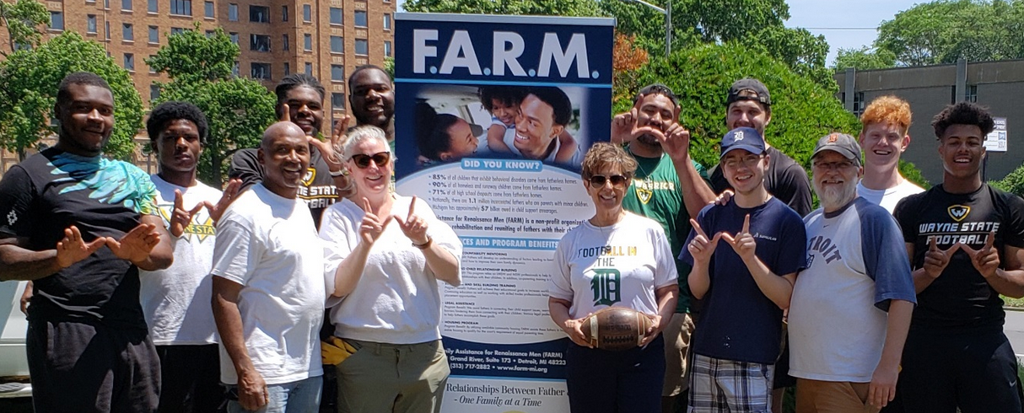
FARM volunteers include WSU football players, staff and other undergrads. FARM founder and CEO Willie Bell and WSU professor Carolyn Dayton in white shirts front row, left.

Wayne State Social Work Partners to Help Detroit Fathers

DETROIT – Wayne State University School of Social Work has partnered with FARM on a $400,000 2-year grant to empower Detroit fathers to enhance their parenting, find employment and support their families. Family Assistance for Renaissance Men (FARM) is a Detroit-based non-profit working to strengthen families by teaching men the principals of fatherhood and building employment skills. It received the award from the Department of Health and Human Services to develop a dynamic and sustainable evaluation system to measure its impact on participants.

The project’s program evaluator is Carolyn Dayton, PhD, LMSW, an associate professor of social work jointly appointed to the Merrill Palmer Skillman Institute for Child & Family Development. For several years, she has directed FARM’s program evaluation and data collection. “Our goal is a comprehensive evaluation plan that can scale up as the program expands,” Dayton said. “We want to demonstrate that our Family Intervention Model focused on engaging fathers really works.”

Many FARM participants grew up without fathers, suffer from high levels of depression and low self-esteem, and were exposed to high levels of stressors, including violence, as children and adults. These risk factors leave them vulnerable to legal problems, low or no employment, and difficulties staying connected with their children.

FARM offers mentoring, education, stable housing options, counseling, father and child relationship building, and legal assistance. It has also developed close working relationships with area construction companies that hire FARM graduates, creating a robust “training to jobs” pipeline for fathers. A preliminary program evaluation by Dayton in 2020 found that 71% of FARM participants were unemployed when they started the program and only 7% were unemployed at the program’s completion. Evaluations also found large decreases in symptoms of emotional distress and increases in parenting confidence.

The enhanced evaluation process will include pre- and post-surveys across multiple domains such as employment and mental health, analysis of the FARM application form, long-term tracking of participant outcomes, and a resource tracking tool to document referral outcomes.

Dayton will work on the evaluations with Bakari Wallace, PhD, a social work post-doctoral student. The grant was submitted by Charlie Grose, FARM’s primary grant writer and an adjunct professor in WSU’s Political Science Master of Public Administration / Nonprofit Management Certificate Program.

The Merrill Palmer Skillman Institute for Child & Family Development promotes and improves
the well-being of children and families across the lifespan through research, education and outreach. The institute is part of Wayne State University, one of the nation’s preeminent public research universities in an urban setting. For more information about research at Wayne State University, visit research.wayne.edu.

